Work Sheet 2

NAME: MOHAMED MIGDHADH

STUDENT ID: S2200065 (VILLA COLLEGE) | 22023480 (UWE)

MODULE CODE: UFCEVK-15-2

MODULE TITLE: INTERNET OF THINGS

**Introduction:**

The task of this work sheet was to Implement a simple communication protocol that transmits data between 2 BBC Micro:bit devices, using GPIOs. For the protocol I have chosen morse code. And the code was written in Micro:bit python editor. Once the code is flashed to the Micro:bit it will act as a transceiver (both transmitter and received)

**Design steps:**

1. Set up all the necessary modules as shown below.
2. The alphabet and number storage, as well as the corresponding morse code storage are declared as shown below.

1. “microbit.display.show(alphabet_numbers[alph_num_index])” is used to display the current character to be sent.
2. “if microbit.button_a.is_pressed() ==1:” this code is used to check if the button A is pressed and if true increment the index by one. If index is out of bounds, reset it to 0.
3. “if microbit.button_b.is_pressed() ==1:” is used to check if the button B is pressed and if true “radio.send(morse_code[alph_num_index])” will broad cast the corresponding morse code string to all other devices in the group.

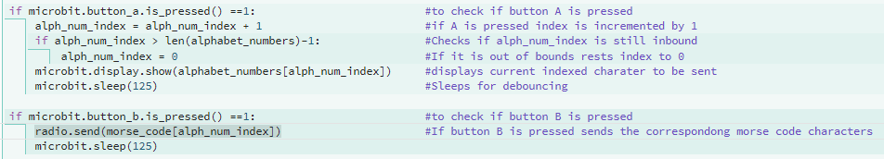

1. “incoming = radio.receive()” this code allows the other devices to grab the incoming broadcast messages.
2. Once the incoming message is received the string of morse code is scrolled on the led screen of the Micro:bit using “microbit.display.scroll(incoming)”



**Inputs and their corresponding outputs:**

* Button A is pressed.

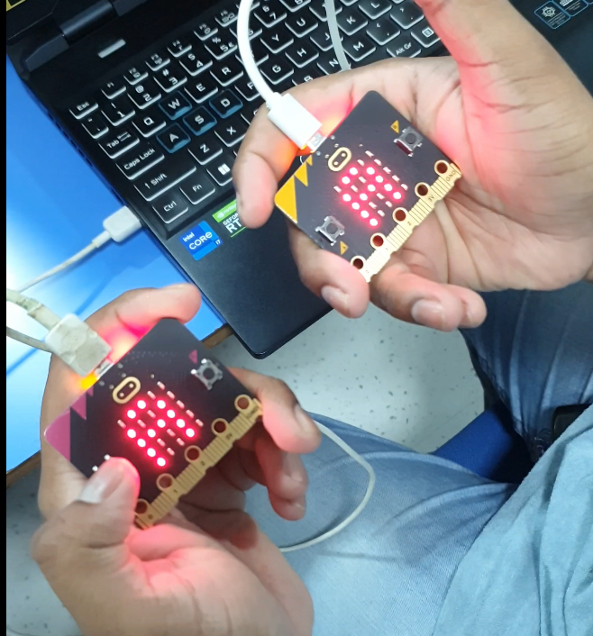

(Before A is pressed)

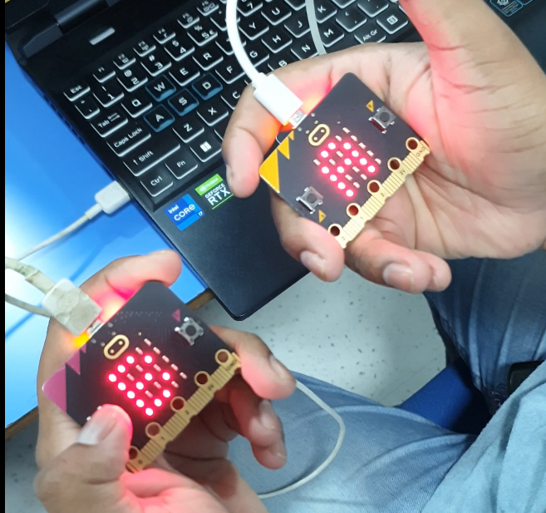

(After A is pressed)

* Button B is pressed.

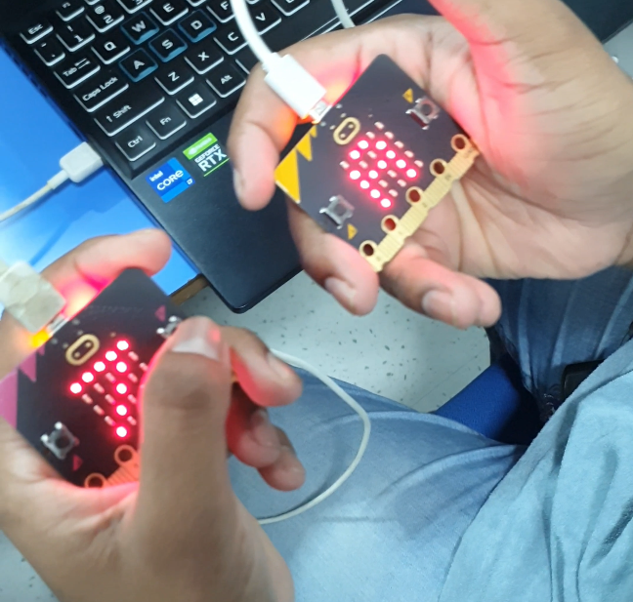

(Before B is pressed)

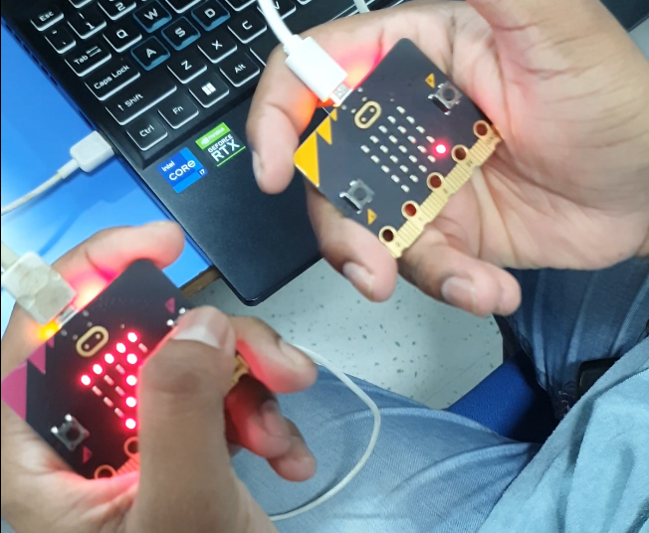

(After B is pressed)